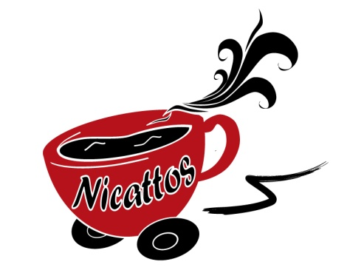
Meal Deals:-

1. Sandwich/Roll, soft drink and traybake/crisps or flapjack - £3
2. Sandwich, soft drink and muffin - £3.30
3. Sandwich and any coffee/hot choc - £3.50
4. Sandwich and Soup -£3.30
5. Sandwich, coffee and traybake, flapjack or crisps - £4
6. Sandwich, coffee and Muffin - £4.30
7. Soup and Buttered Roll - £1.85
For a Wrap/Baguette/Pasta Salad Meal Deal add 50p to the above
For a Salad Meal Deal add 80p to the above
How to order
1. We will stock a variety of sandwiches daily on the van so you can simply ask. (However to ensure our sandwiches are as fresh as possible we only stock a limited number a day)
2. Telephone order:- Call (01382) 581079 or 07925694957 to place your order. Orders placed before 10am will be made up and ready for collection from the van on our daily round.
3. Website order:- Visit www.nicattos.co.uk and fill out our order form or simply email your order to sandwiches@nicattos.co.uk (Orders placed before 10am will be made up and ready for collection from the van on our daily round.)
Meeting Catering is available on a per head basis, please ask for prices and details.

